**DEDAN KIMATHI UNIVERSITY OF TECHNOLOGY**

**SCHOOL OF ENGINEERING**

**DEPARTMENT OF MECHATRONIC ENGINEERING**

**DYNAMIC SPEED GOVERNOR FOR HOTSPOT AND SPEED RATED AREAS**

**SUPERVISOR: MR SAMMY**

**FULL NAME REGISTRATION NO.**

* **Farries Ngai Seda E022-01-1084/2020**
* **Joseph Gichuki Mbathi E022-01-1022/2020**
* **Brian Ayekha E022-01-2101/2020**
* **Bernard Kimani Mugwe E022-01-1076/2020**
* **Victoria Sitati E022-01-1076/2020**
* **Ian Kiptoo E022-01-1074/2020**
* **Dennis Karanja Njuguna E022-01-1030/2020**
* **Wainaina Joseph Kamau E022-01-1014/2020**
* **Joan Kabura E022-01-0935/2020**
* **Andera Neville E022-01-0815/2019**
* **Moses Mwangi Kangethe E022-01-1041/2020**
* **Nathaniel Joash Mwaniki E022-01-1020/2020**
* **LUQMAN ALI E022-01-2113/2020**
* **Joash Kiprotich E022-01-1594/2020**
* **Joe Albert Ngigi E022-01-1055/2020**
* **Julius Mghanga E022-01-1054/2020**

**Objectives**

**Main »** To design a working dynamic speed governing mechanism for vehicles.

**Minor**

* To establish how to code for Arduino Uno and use it as a micro controller
* To familiarize with IR and RF modules
* To use kicad and Proteus software in designing PCBs and circuits

**Theory**

Nowadays people are driving very fast; accidents are occurring frequently, we lost our valuable life by making mistakes while driving (school zones, hills area, and highways). So in order to avoid such kind of accidents and to alert the drivers and to control their vehicle speed in such kind of places the highway department have placed the signboards. The project aims to intimate the driver about the zones and the speed limit automatically, which is done by means of using RF technology. The objective of this project is to automatically control the speed of the vehicles at speed restricted areas such as school and hospital zone, U-turn etc. and accident avoidance using ultrasonic sensor.

At particular zone special kind of transmitters which are tuned at a frequency of 433MHZ are mounted. These transmitters continuously radiate RF signal. When the vehicle comes within this radiation the receiver in the vehicle gets activated. Whenever the vehicle is within the zone, the vehicle speed is controlled by receiving the signal i.e. every time the vehicle speed is decreased to some cutoff and kept constant until the vehicle moves out of the zone, and then the vehicle can get accelerated by itself.

**COMPONENTS**

* **Radio frequency transmitter module –** It is a small PCB sub-assembly capable of transmitting a radio wave and modulating that wave to carry data.
* **Encoder – (**HT12E**) –** Converts parallel inputs into serial output. It encodes the 12 bit parallel data into serial for transmission through an RF transmitter. These 12 bit are divided into 8 address bit and 4 data bits.
* **Radio frequency receiver module –** It is a device that accepts radio frequencies from a remote transmitter.
* **Decoder –** Used after the RF receiver to decode the serial format and retrieve the original signals as outputs.
* **Voltage regulator –** It is system designed to automatically maintain a constant voltage.
* **Microcontroller –** Is a small computer on a single metal-oxide-semiconductor VLSI integrated circuit chip. It contains one or more CPUs along with memory and programmable input/output peripherals.
* **Resistors –** It is a passive two-terminal electrical component that implements electrical resistance as a circuit element.
* **Push-buttons –** It is a simple switch mechanism to control some aspects of a machine or a process.
* **Led-** Use to indicate the limit being set in by the remote on the receiver.

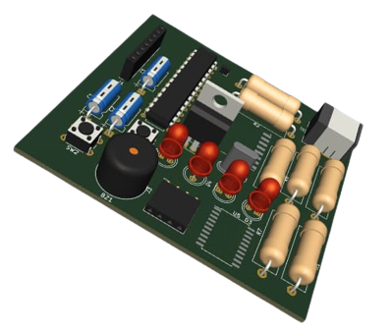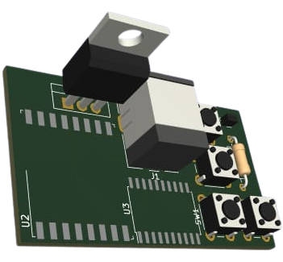

**PROJECT PROCEDURE:**

This involved the design of a transmitter and receiver circuit simulation as well as PCB using Proteus and KiCAD. Furthermore, there was design of an infrared-based circuit simulation and PCB using the same.

**CONCLUSION**

The strategy for this project was to produce a much easily operable and reliable device

This design explains the vehicle speed controller based on the RF technology. It has explained how transmitters installed some roads sections and receivers installed in vehicles can be used to communicate with the each other thereby providing control over the vehicle speed. The design approach was based on a combination of two block units which are the transmitter and the receiver

The results obtained were promising and show that this design can be a potential vehicle speed governor because of its capacity to influence the receiver speed, by giving some expected limits i.e. in the empirical trials, the receiver’s speed was successfully changed as a result of the detection of the signals from the transmitter. This would mean that the design can be more reliable, effective and can be a lasting solution in curbing over speeding in Kenya if fully implemented

The design also worked well for a close range of about 20cm between the transmitter and the receiver because of low transmit power and the value of each speed limit test was then displayed on the LCD display at the receiver side.

Thus, there can be hope to revolutionize the traffic management and avoid accidents caused due to over speeding in the near future of Kenya.

**RECOMMENDATIONS**

• Provision of tools that emulate the external real application environment such as a real vehicle for testing the performance of the developed RF based vehicle speed governor

• Modification may be done on signal processing for digital speed display. The speed controller algorithm developed for this speed governor was based on Pulse Width Modulation (PMW) technique at the receiver end, but other control mechanisms such as fuzzy logic system may also be adopted to give accurate reasoning, acceptable reasoning and also help to deal with uncertainty in the designing process.

• Further work can be carried out to study how different frequencies avoid high chances of channel interferences in cases of co-located zones/sections of the roads. The 433MHz technology holds less information and the technology itself is very rudimentary. The 433MHz signals are typically only one-way. This however makes the 433 MHz devices, less reliable. So, further research can be carried out using other technologies like Zig Bee (2.4GHz) or Z-Wave (868.42 MHz) for testing purposes.

• Instead of the radio frequency we could have used GPS solutions such as Google Maps to reduce hardware costs and increase coverage.

• Accessibility to components needed to achieve the goals of the project

**REFERENCES**

How a Car Works “How a fuel injection system works”, howacarworks.com, [online] Available, https://www.howacarworks.com/basics/how-a-fuel-injection-system-works

Arduino “Get Started with Arduino Uno”, Arduino.cc, [online] Available https://www.arduino.cc/en/Guide/ArduinoUno

Robot Platform “Dual H-bridge Motor Driver - L293D IC”, robotplatform.com, [online] Available [https://www.robotplatform.com/howto/L293/motor_driver_1.html

Lastminute Engineers “How 433MHz RF Tx-Rx Modules Work & Interface with Arduino”, lastminuteenineers.com, [active] Available, https://lastminuteengineers.com/433mhz-rf-wireless-arduino-tutorial/

RoadSafetyNz “How Do Modern Speed Limiters Work?”, roadsafetynz.org, [online] Available, http://www.roadsafetynz.org/modern-speed-limiters.html